**UML Assignment**

1. Class Diagram (Airline Reservation System)

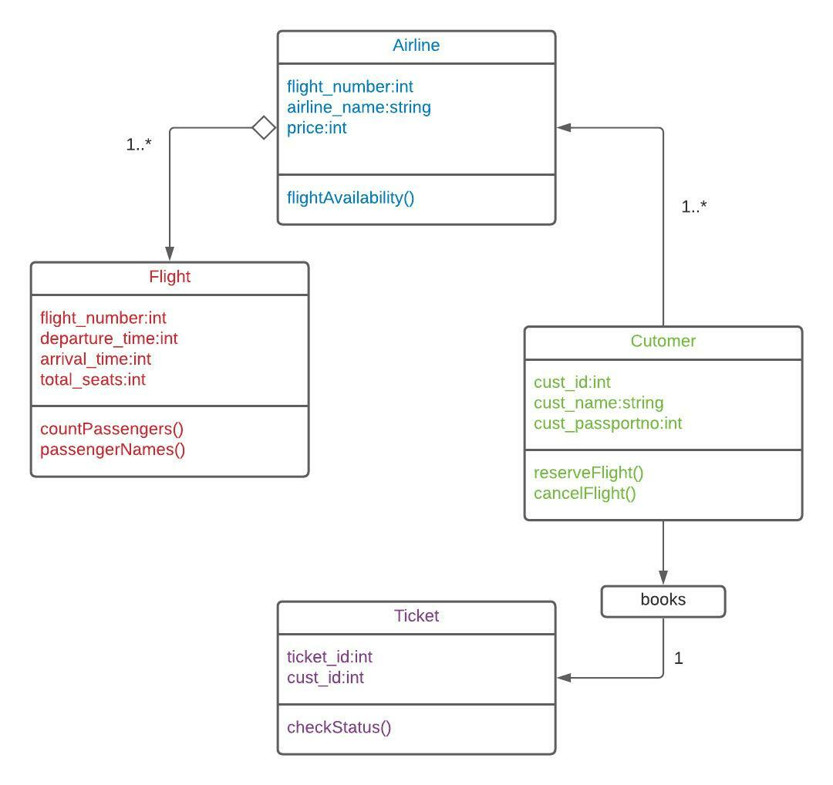

1. Class Diagram (University)

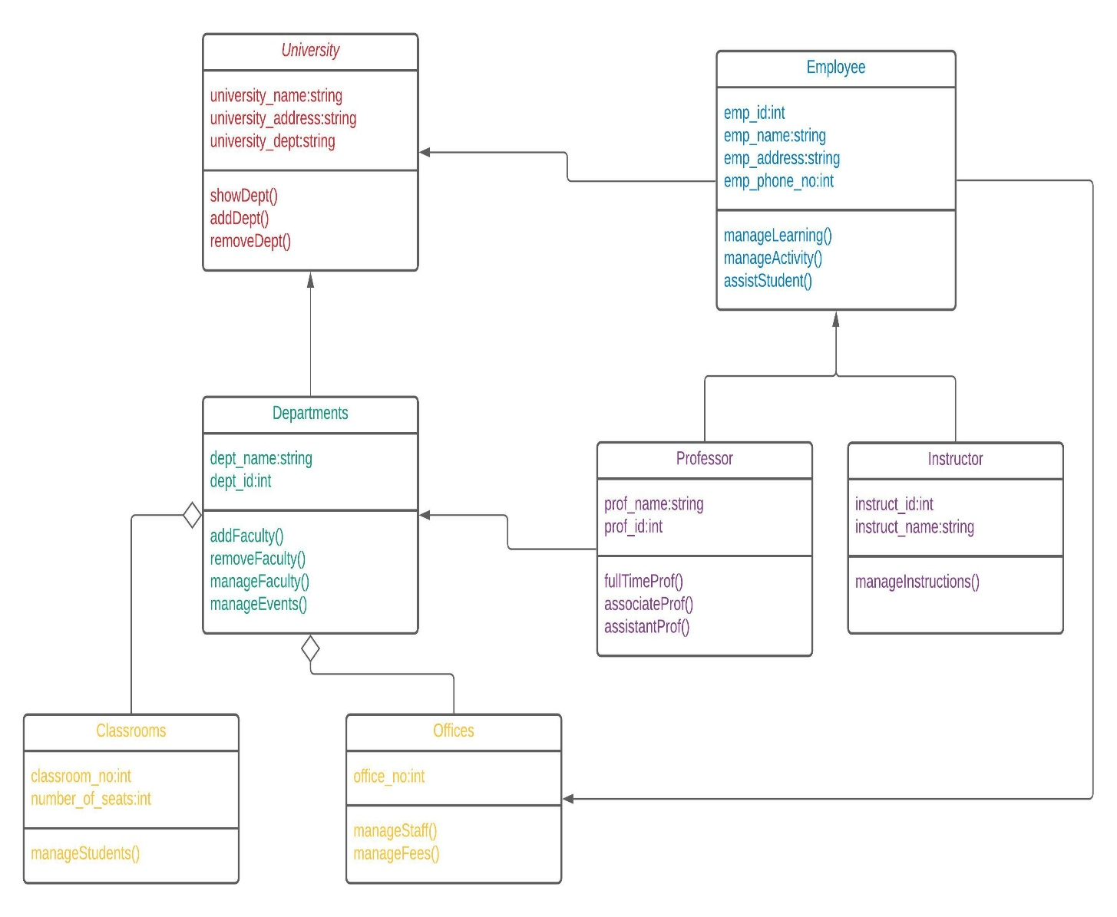

1. Activity Diagram (Student Enrolment )

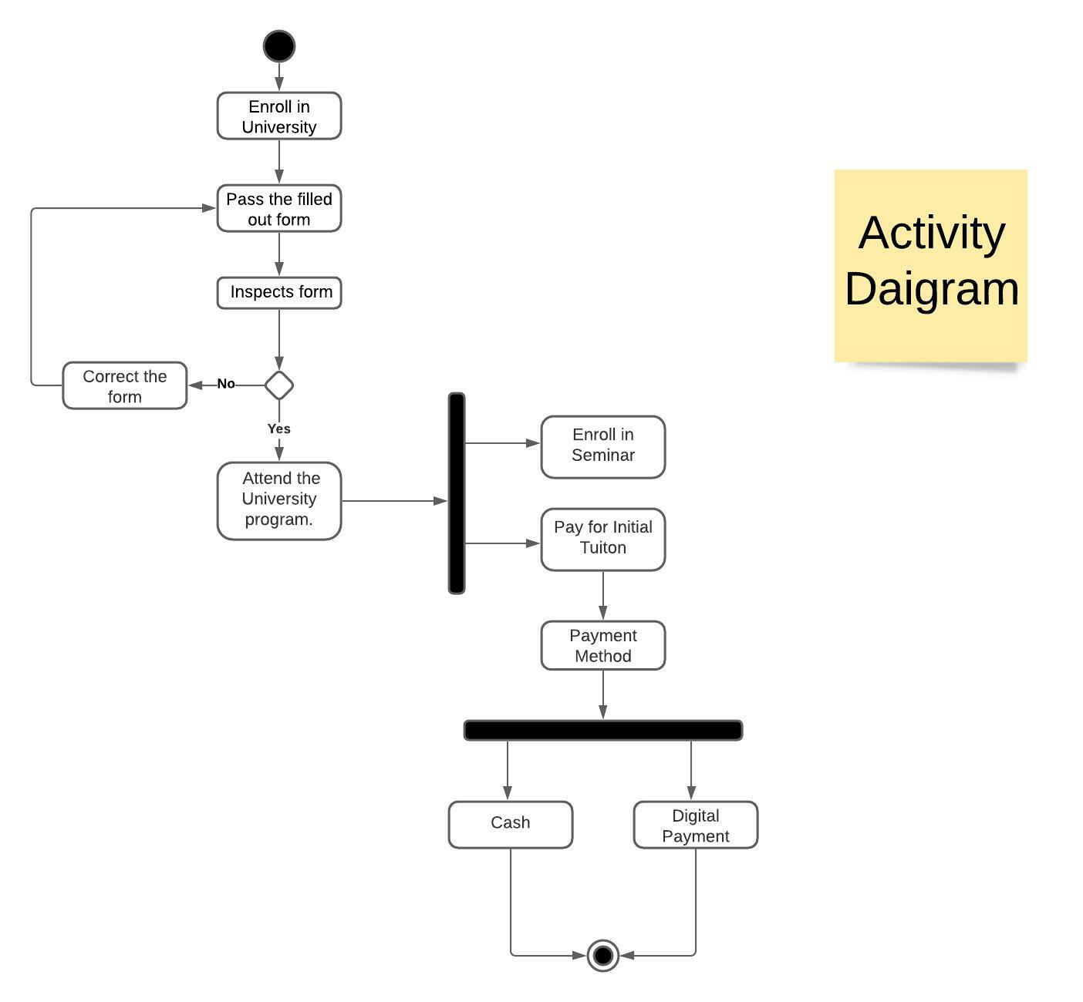

1. Sequence Diagram (Online Library Management)

